Do not send Windows usernames and passwords to Vault!!!
Yes, I know the login dialog makes it look like this information is going to Vault, but that’s not how it works at the API level.
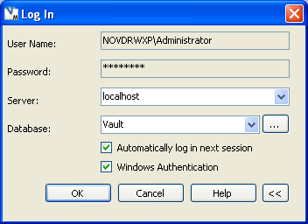
What is really going on is that the Win Auth Service is used to sign into Vault instead of the Security Service.
When you sign in through the Win Auth Service, you do not pass in any usernames or passwords. Instead you indicate that you want to use Windows credentials when making the HTTP request. Once signed in, the security credentials can be copied over to the other web service objects, just like with the Security Service.
Here, have some sample code. Note that only the Vault name is passed in to SignIn().
C#:
// login to the Vault and set up the document service
WinAuthService winAuthSvc = new WinAuthService();
// NOTE: The WinAuthService is in a different folder than the other services
winAuthSvc.Url = "http://localhost/AutodeskDM/Services/WinAuth/WinAuthService.asmx";
winAuthSvc.UseDefaultCredentials = true;
winAuthSvc.SecurityHeaderValue = new WinAuth.SecurityHeader();
winAuthSvc.SignIn("Vault");
DocumentServiceWse docSvc = new DocumentServiceWse();
docSvc.Url = "http://localhost/AutodeskDM/Services/DocumentService.asmx";
docSvc.SecurityHeaderValue = new Document.SecurityHeader();
docSvc.SecurityHeaderValue.Ticket = winAuthSvc.SecurityHeaderValue.Ticket;
docSvc.SecurityHeaderValue.UserId = winAuthSvc.SecurityHeaderValue.UserId;

VB.NET:
' login to the Vault and set up the document service
dim winAuthSvc as WinAuthService = new WinAuthService()
' NOTE: The WinAuthService is in a different folder than the other services
winAuthSvc.Url = "http://localhost/AutodeskDM/Services/WinAuth/WinAuthService.asmx"
winAuthSvc.UseDefaultCredentials = true
winAuthSvc.SecurityHeaderValue = new WinAuth.SecurityHeader()
winAuthSvc.SignIn("Vault")
dim docSvc as DocumentServiceWse = new DocumentServiceWse()
docSvc.Url = "http://localhost/AutodeskDM/Services/DocumentService.asmx"
docSvc.SecurityHeaderValue = new Document.SecurityHeader()
docSvc.SecurityHeaderValue.Ticket = winAuthSvc.SecurityHeaderValue.Ticket
docSvc.SecurityHeaderValue.UserId = winAuthSvc.SecurityHeaderValue.UserId

